**Design Thinking Project Workbook**

**Don't find customers for your product but find products for your customers**

**1. Team**

**Team Name:**

**Team Logo (if any):**

**Team Members:**

1. **Sadhana, 2320030182@klh.edu.in**
2. **Avinash, 2320030185@klh.edu.in**
3. **K Jayakrishna, 2320030191@klh.edu.in**

**2. Problem/Opportunity Domain**

**Domain of Interest: The specific industry or field where your innovative idea will be applied.**

Puzzle Games and Artificial Intelligence

**Description of the Domain: A brief overview of the key elements, challenges, and opportunities within the domain.**

The 8-puzzle game is a classic problem in the field of Artificial Intelligence and heuristic search algorithms. The game involves moving tiles on a 3x3 grid to achieve a specified goal state, often with a minimum number of moves. Challenges include pathfinding efficiency, heuristic development, and achieving optimal solutions.

**Why did you choose this domain?: The personal or strategic reasons for selecting this domain, such as passion, market potential, or solving a specific problem.**

This domain is chosen due to its applicability in AI research, specifically for developing and testing search algorithms like A*, greedy search, and BFS. It's a well-defined problem with a manageable state space, making it suitable for learning AI concepts

**3. Problem/Opportunity Statement**

**Problem Statement: A clear and specific articulation of the problem, outlining its importance.**

Efficiently solving the 8-puzzle game to achieve the goal state with the fewest possible moves.

**Problem Description: A concise explanation of the issue or challenge that needs to be solved.**

The challenge lies in finding an optimal sequence of moves from a random initial state to a goal state. Many solutions are computationally expensive, and users often struggle to find the most efficient solution manually**.**

**Context (When does the problem occur): The specific situations or conditions under which the problem arises.**

The problem occurs when a user attempts to solve the 8-puzzle manually or when designing an AI to solve the puzzle as part of an educational or research project.

**Alternatives (What does the customer do to fix the problem): Existing solutions or actions taken by customers to address the issue.**

Users can attempt trial-and-error manually, use existing apps or algorithms, or follow basic heuristics without guarantees of optimality.

**Customers (Who has the problem most often): The primary group of individuals or organizations affected by the problem.**

AI students, researchers, educators, and puzzle enthusiasts.

**Emotional Impact (How does the customer feel): The emotions or frustrations experienced by the customer due to the problem.**

Users often feel frustrated by the difficulty of finding an efficient solution, especially when trying manually.

**Quantifiable Impact (What is the measurable impact): The measurable effects of the problem, such as financial losses or time wasted.**

Time taken to solve the puzzle, number of moves, computational resources used.

**Alternative Shortcomings (What are the disadvantages of the alternatives): The limitations or downsides of the current solutions customers use.**

Manual solving is time-consuming, and non-optimal algorithms may result in excessive computational costs.

**Any Video or Images to showcase the problem: The evidence in the form of video or image).**

**Provide link if available**

**4. Addressing SDGs**

**Relevant Sustainable Development Goals (SDGs): Identify which of the 17 SDGs are directly impacted by the problem or opportunity.**

The 8-puzzle game simulation directly impacts SDG 4 (Quality Education) by enhancing computational skills, SDG 9 (Industry, Innovation, and Infrastructure) through AI research, SDG 8 (Decent Work and Economic Growth) by improving employability in tech, and SDG 17 (Partnerships for the Goals) by fostering educational collaboration.

**How does your problem/opportunity address these SDGs?: Describe how solving the problem or leveraging the opportunity will contribute to achieving one or more SDGs.**

Solving the problem with the 8-puzzle game simulation contributes to SDG 4 by enhancing STEM education and computational skills, SDG 9 by driving innovation in AI algorithms, SDG 8 by equipping learners with in-demand tech skills for better job prospects, and SDG 17 by promoting global collaboration in educational tools and research.

**5. Stakeholders**

Answer these below questions to understand the stakeholder related to your project

1. **Who are the key stakeholders involved in or affected by this project?**

The key stakeholders are students, educators, researchers, and puzzle enthusiasts interested in AI and computational learning.

1. **What roles do the stakeholders play in the success of the innovation?**

Students learn and apply problem-solving skills, educators integrate the tool into teaching, researchers use it to test algorithms, and puzzle enthusiasts engage with and promote the simulation.

1. **What are the main interests and concerns of each stakeholder?**

Students seek learning, educators aim for effective teaching, researchers focus on algorithm testing, and puzzle enthusiasts desire challenge and enjoyment.

1. **How much influence does each stakeholder have on the outcome of the project?**

Educators and researchers have high influence, as they shape the tool's educational and technical aspects, while students and puzzle enthusiasts have moderate influence through user feedback and engagement.

1. **What is the level of engagement or support expected from each stakeholder?**

High engagement is expected from educators and researchers for development and testing, while moderate engagement is expected from students and puzzle enthusiasts for usage and feedback.

1. **Are there any conflicts of interest between stakeholders? If so, how can they be addressed?**

Potential conflicts may arise between researchers seeking complex features and students needing simplicity; these can be addressed by offering adjustable difficulty levels and customizable settings to balance both needs.

1. **How will you communicate and collaborate with stakeholders throughout the project?**

Communication and collaboration will be maintained through regular feedback sessions, interactive demos, educational workshops, and online forums to gather insights and update stakeholders on progress.

1. **What potential risks do stakeholders bring to the project, and how can these be mitigated?**

Stakeholders may bring risks such as resistance to adopting new technology (educators), limited user engagement (students), or technical challenges (researchers); these can be mitigated through thorough training, user-friendly design, and continuous support.

**6. Power Interest Matrix of Stakeholders**

**Power Interest Matrix: Provide a diagrammatic representation of Power Interest Matrix**

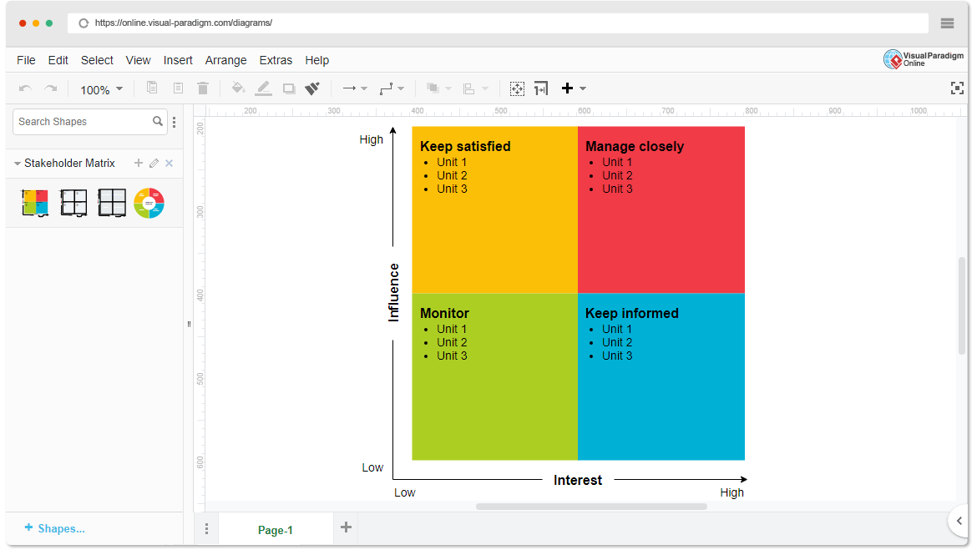

* High Power, High Interest: Educators, Researchers
* High Power, Low Interest: Developers of AI educational tools
* Low Power, High Interest: Students, Puzzle Enthusiasts
* Low Power, Low Interest: Casual users not involved in AI